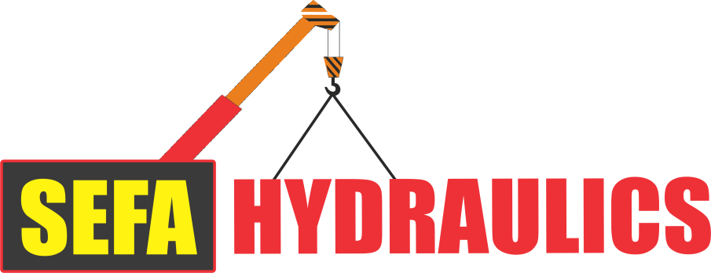
SEFA HYDRAULICS REG NR: 2015/363301/07 62 PLATINUM STREET, LADINE, POLOKWANE E-MAIL: ADMIN@SEFAHYDRAULICS.CO.ZA VAT: 4420275606 OFFICE: 015 010 1089
CELL: 0798059463 / 0834142590
SALES REP: Marius 061 524 0218 SALES REP: Peter 068 196 4535

BUSINESS PROFILE OF SEFAKONONG TRADING (PTY) LTD
(SEFA HYDRAULICS, PALFINGER)

COMPANY INFORMATION:

Registered Name: Sefakonong Trading (Pty) Ltd

Trading Name: Sefa Hydraulics

Office address: 62 Platinum Street
Ladine
Polokwane

Postal Address: 62 Platinum Street
Ladine
Polokwane
;
Contact Details: Office:015 010 1085
Cell: 079 805 9463
E-mail: admin@sefahydraulics.co.za

Contact Persons: Mr. Loggenberg (Director) -079 805 9463 (Director)
Mr. Buthane (Director) - 083 414 2590 (Director)
Miss Olivier (Office admin, Financial)- 082 717 9320
Mr. Marius Robberts (Sales Rep) -061 524 0218 /076 903 9453
E-mail: sefa@sefahydraulics.co.za Mr. Peter Rasebeka (Sales Rep) – 0735455305 E-mail: sefa@sefahydraulics.co.za

SEFA HYDRAULICS REG NR: 2015/363301/07 62 PLATINUM STREET, LADINE, POLOKWANE E-MAIL: ADMIN@SEFAHYDRAULICS.CO.ZA VAT: 4420275606 OFFICE: 015 010 1085
CELL: 0798059463 / 0834142590
SALES REP: Marius 061 524 0218 SALES REP Peter 068 196 4532

BUSINESS PROFILE OF SEFAKONONG TRADING (PTY) LTD
(SEFA HYDRAULICS, PALFINGER)

SEFAKONONG TRADING (PTY) LTD is a well-established and focused specializing on Hydraulics, Cylinders, Valve Banks, Pumps, Hoses and new Crane Sales. Our Company (staff) are committed to providing to your every need, while under no circumstances compromising on quality and service excellence. Worldwide, PALFINGER stands for the most innovative, reliable and cost-effective lifting solutions for use on commercial vehicles and in the maritime field. With our technological expertise and experienced staff, we set quality benchmarks in the industries. Stablished in 1932 and for many years now an international leader in innovative hydraulic lifting systems – that is the PALFINGER success story. The Company’s history is defined by three key stages: the pioneering phase, the era of the crane, and the period of expansion. Today, PALFINGER is a worldwide group that is always to the customer, no matter the location.

OUR VISSION AND MISSION:

- To supply unsurpassed quality products
- To deliver reliable aftersales service
- To continue providing high-tech solutions for seamless loading and transport logistics
- To be the market leader
- To ensure ethical business values

VALUES:

LEADERSHIP
“Leaders become great, not because of their power, but because of their ability to empower other”.
INTERGRITY
“People may doubt what you say, but they will always believe what you do”
ACCOUNTABILITY
“It is not only what we do, but also what we do not do for which we are accountable”
PASSION
“The only way to do great work is to love what you do”
OPTIMISM
“The ones who are crazy enough to think that they can change the world, are the ones who do”
COMMITMENT
“Commitment is doing the thing you said you were going to do long after the mood you said it in has left you”
TEAMWORK
“If you want to go fast, go alone. If you want to go far, go together”

FURTHER MORE WE BELIEVE IN

- Running a company capable of developing more skills and capacity able to handle the growing volume of work as the business grows.
- Business standards and top quality service at all times.
- Profitability and growth of the business.

OUR CORE BUSINESS

The core business of this great company SEFA HYDRAULICS is Hydraulic repairs, Crane Sales, PML’s, Canopies, Ladder Racks, Remotes and so much more in any way that we could assist you as a client. PLEASE ALSO SEE LAST PAGE FOR OUR NEW PRODUCTS WE DO NOW!!!!

MAIN PRODUCTS

- PALFINGER CRANES;
- PML’S;
- CANOPIES;
- INSTALLATIONS;
- LADDER RACKS;
- REMOTES;
- AUTO ELECTRICAL;
- HOOK LIFTS;
- TRUCK MOUNTED FORKLIFTS;
- SKIP LOADERS;
- AERIAL PLATFORMS;
- PRODUCTION LOADERS;
- TAILLIFTS;
- CONTAINER SIDE LOADERS;
- ATTACHMENTS (BRICK GRABS, SCRAP GRABS, TIMBER GRABS, WORKMEN BASKETS; EARTH AUGERS, ROTATORS, PALLET FORKS, TYRE HANDLERS, BARRIER GRABS,)

We do sub-frames any size you require

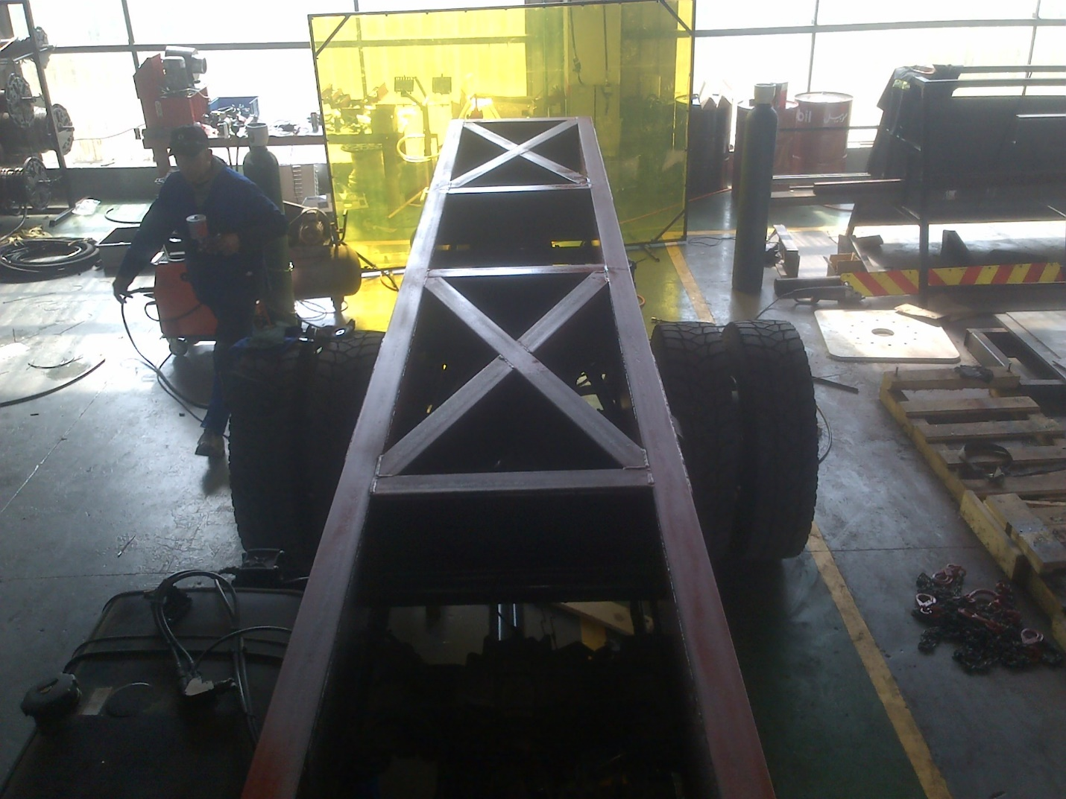
.

We also have the best of experience in Altec Units

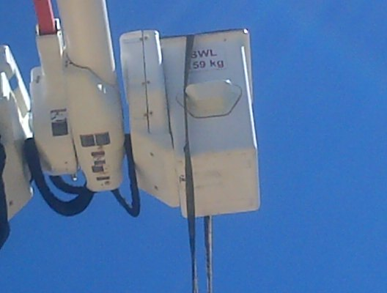
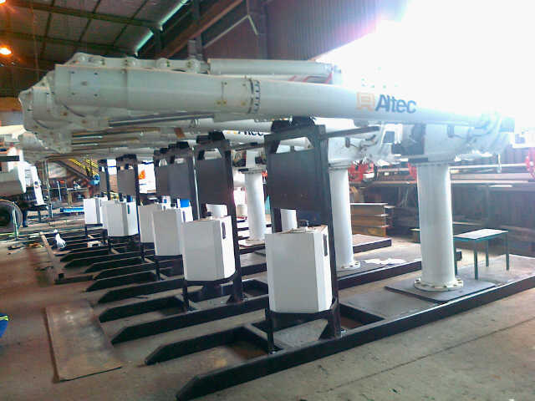

Palfinger is our main Product in the company, although we practisce in more than just Palfinger

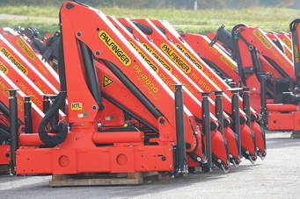

ADDITIONAL INSPECTIONS
It is possible to add tests;
- Load Tests is the more common in this industry;
- We do the Test and also give the Certificate if requested;
- If there is any tests that needs to be done we will also arrange for that and all tests shall be agreed beforehand;

We as Sefakonong Trading (Pty) Ltd think that quality equals the Customer’s comment of our service and products.
MARKET FOCUS
Our market is so big and wide our product can be used in the Marine world on all boats as well as on a normal truck with all the correct stability etc. we will be able to assist you with the best product for the business you are in. Our products can be used in the mines, Building Sides, To offload big items, to move items. We also sell the forklifts for your business. We have a wide range in our products.

OUR FACILITIES AND DEDICATED STAFF

OUR WASHBAY ALWAYS CLEAN AND READY TO WASH YOUR EQUIPMENT WHEN READY TO DELIVER
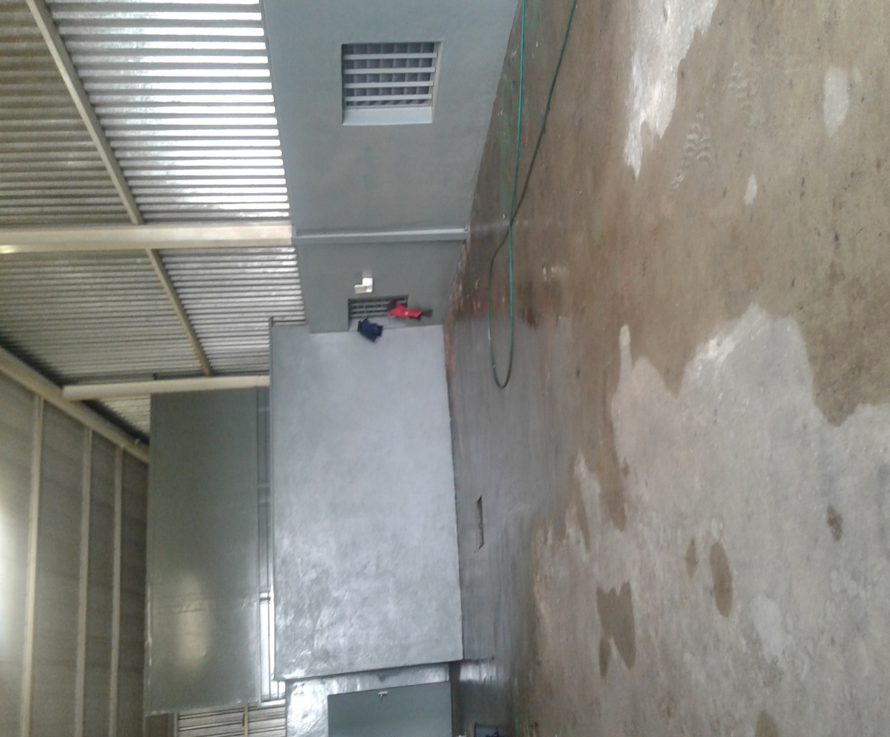

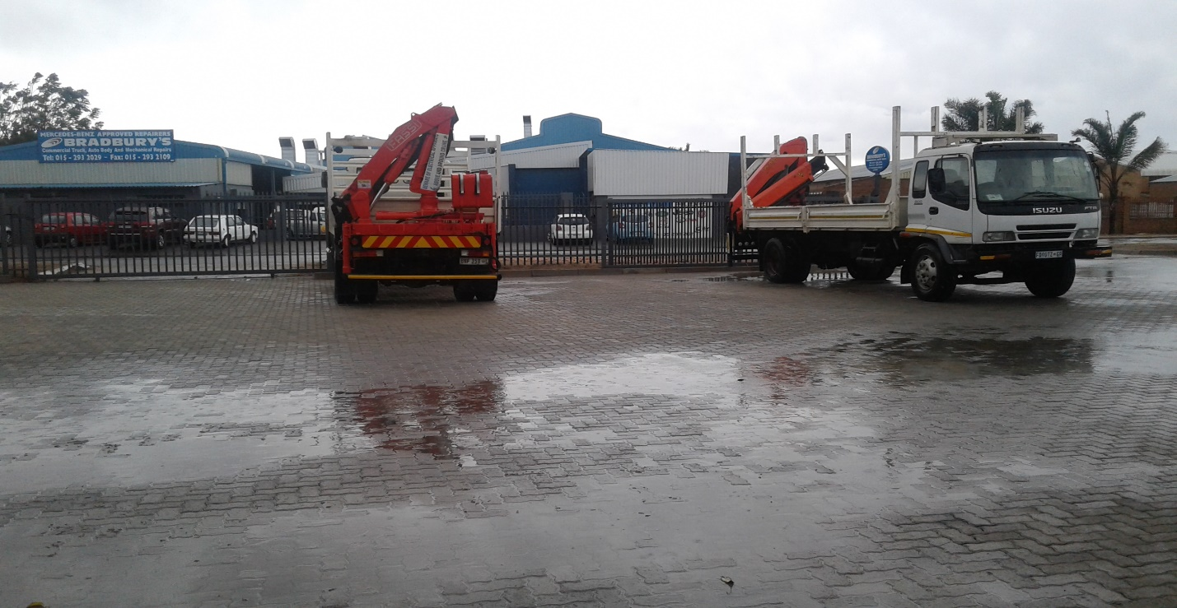
OUR YARD BIG ENOUGH FOR ALL YOUR WORK
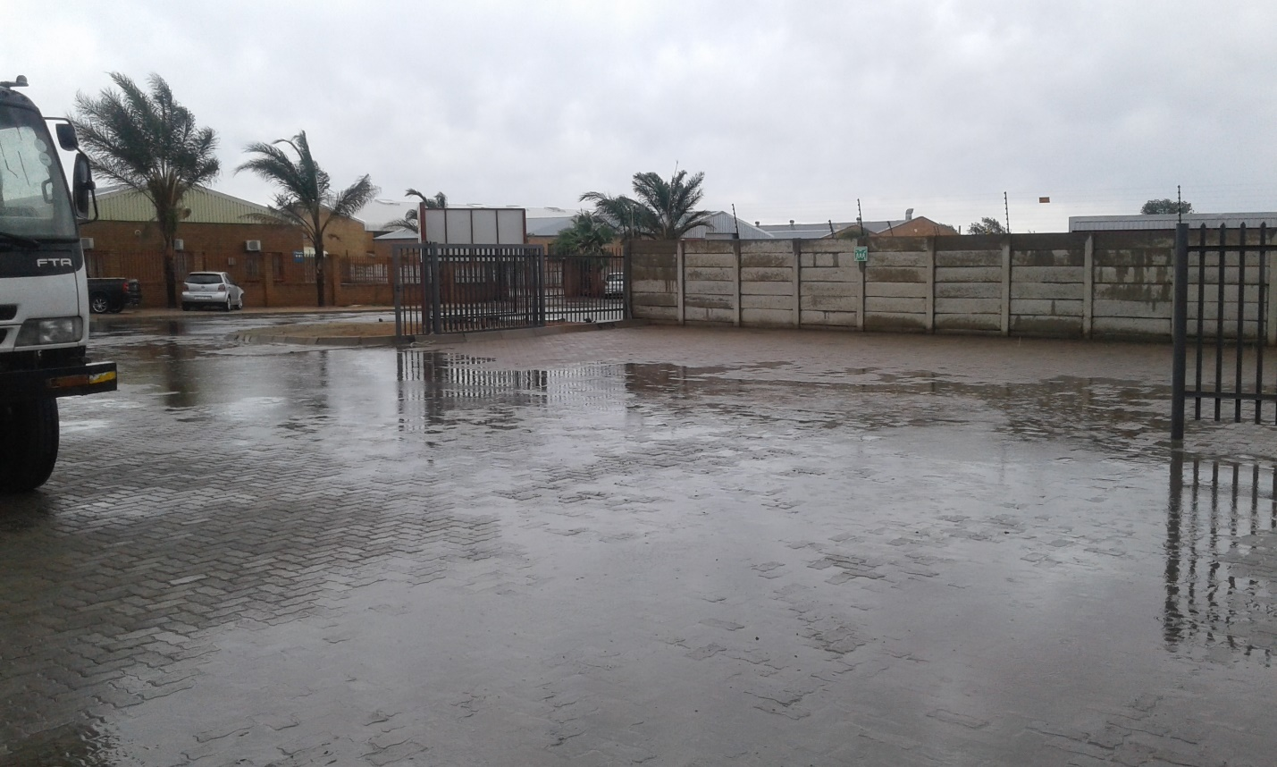

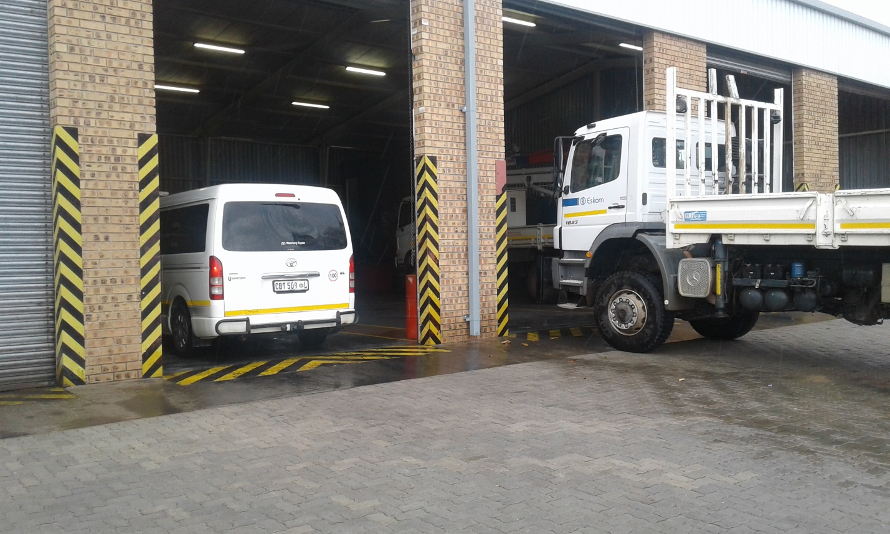
SOME OF THE STAFF BUSY ON A CLIENT’S CRANE
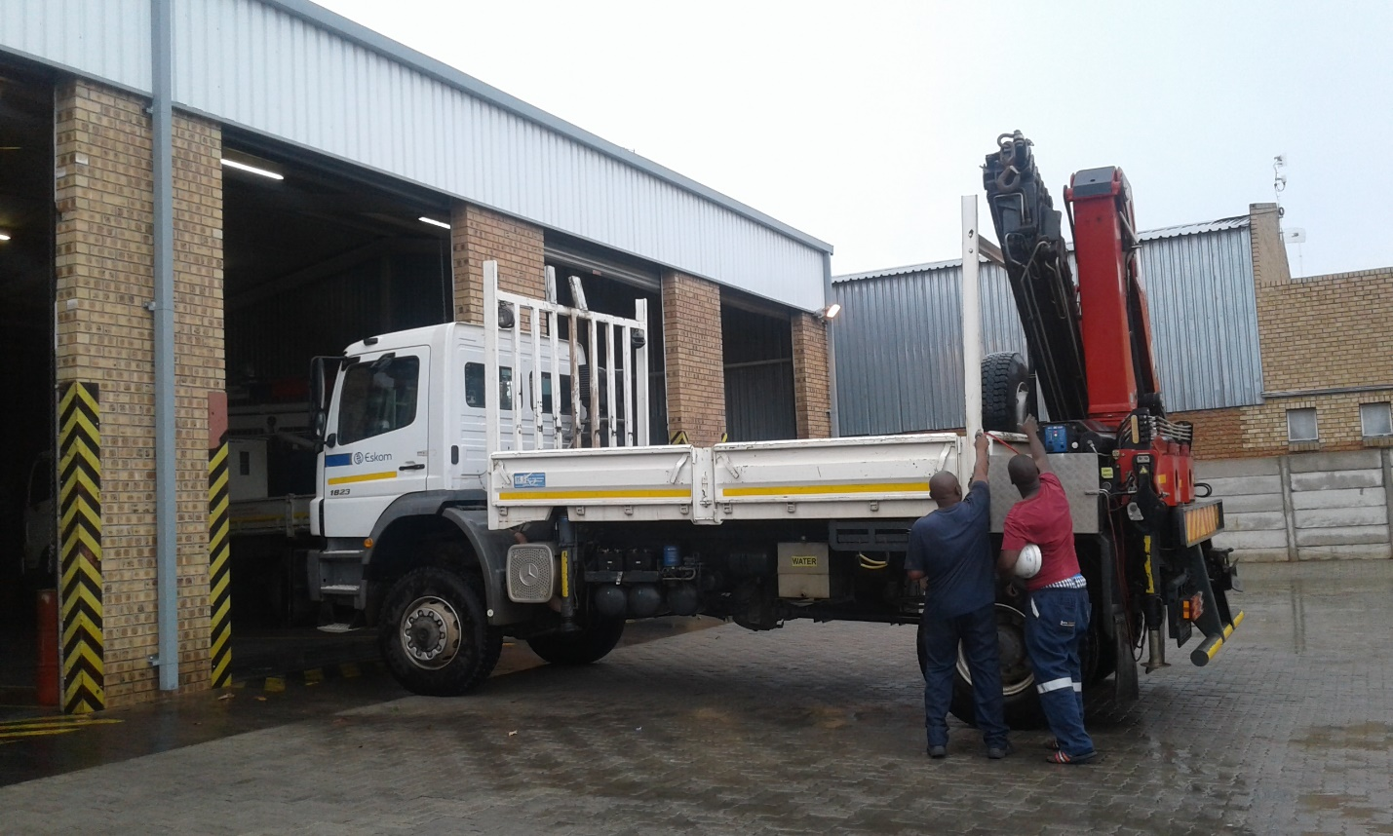
NEW CRANES ALL DIFFERENT SIZES FOR THE CONVENIENCE OF YOUR BUSINESS
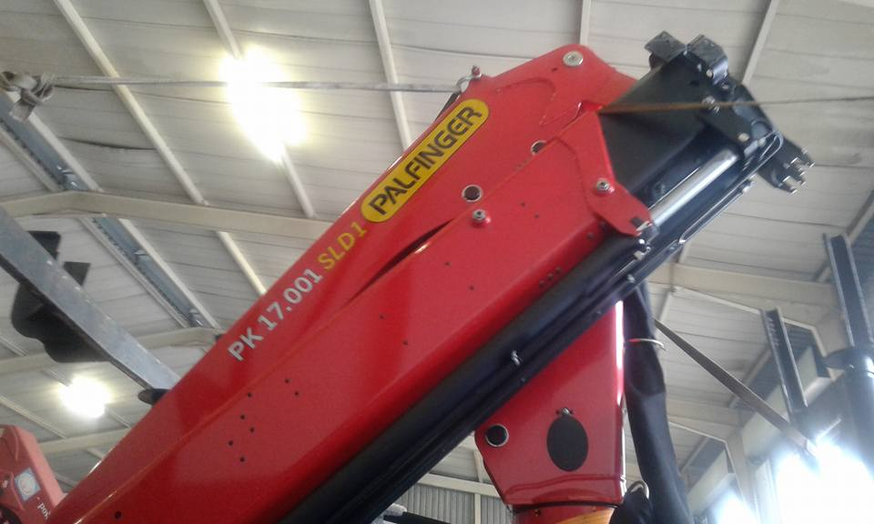
NEW CRANE INSTALLED ON A CLIENT’S TRUCK
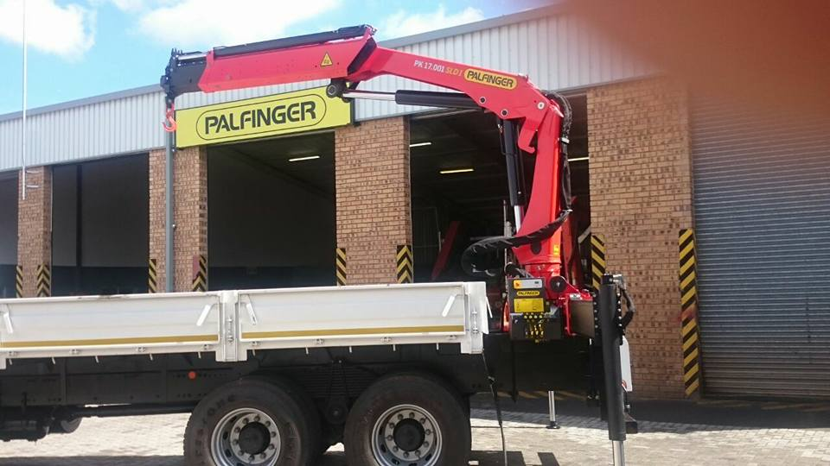
ENGINEERING:
We also qualify in the following on our engineering side:
- Tool Making;
- Manufacture gears;
- Precision Turning;
- Gear Cutting;
- On site Line Boring;
We assist you to the best of our side and will make sure that we keep you happy herein.
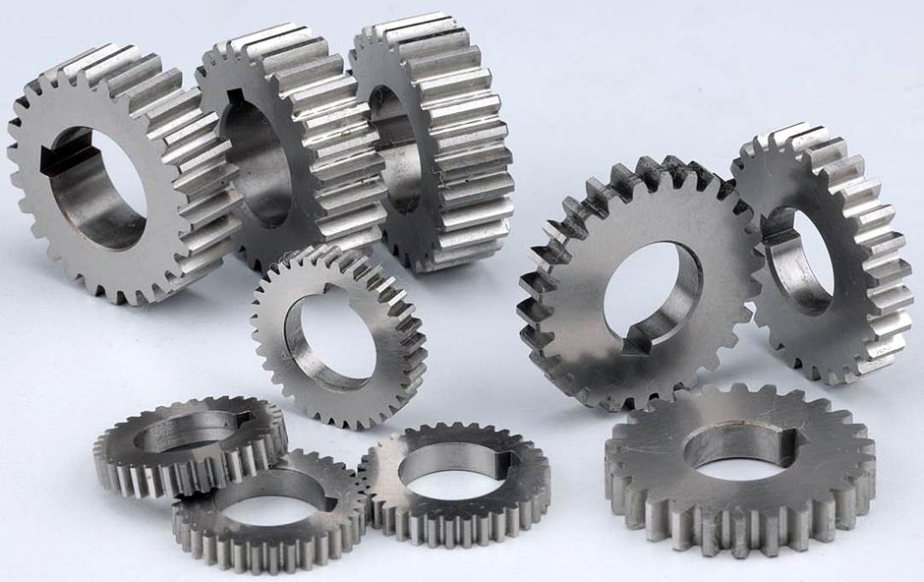

PARTS SIDE:
Parts side we assist and sell in any size of the Hydraulic Pipes you may need. We do have stock and you may require and we will assist at the best of our assistance. We also have 24/7 call out assistance.
